**Lab 0: Setting Up**

Welcome to your first lab! In this lab, we will set up accounts for all the services we will be using in this course. This includes creating an Amazon Developer account, as well as ensuring you have access to Canvas, the learning management system for this course. Let’s get started!

Tip: For the sake of simplicity, I would recommend using the *same* email address to create accounts for each of the following. You may want this to be a personal email, not your school account, so that you can access these accounts in the future (post high school graduation) as well.

**Part I: Confirm Access to LMS <insert name here>**

1. Log into <LMS>, and confirm you can access our course site.
2. Bookmark this site for easy future reference.
3. Now go to “Discussions,” and post the introductory video you made in our first class to the “Introductions” discussion forum. You may attach your video as a file, or post a link to the video if you choose to upload it elsewhere (like YouTube).

**Part II: Create an Amazon Developer Account**

To build any type of Alexa skill, you will need an account on the Amazon [Developer Portal](https://www.amazon.com/ap/signin?clientContext=135-8554935-2084900&openid.return_to=https%3A%2F%2Fdeveloper.amazon.com%2Falexa%2Fconsole%2Fask&openid.identity=http%3A%2F%2Fspecs.openid.net%2Fauth%2F2.0%2Fidentifier_select&openid.assoc_handle=mas_d).

We use the developer portal to create a configuration for the skill. This configuration collects information about the skill, such as its name, the API you want to use, the endpoint or content feed, and other information. The Alexa service uses the configuration to determine which user requests should be sent to the service for your skill. We will talk about this in more detail later.

For now, follow the steps below, or watch this [video](https://www.youtube.com/watch?v=kUwsx4WShgY), to create your own Amazon Developer account.

1. Go to the Amazon Developer console at <https://developer.amazon.com>.
2. Bookmark this as the “Amazon Dev Console.”
3. Click “Sign In” in the top right corner.
4. Click “Create your Amazon Developer account.”
5. You will be required to add some personal information, including:
   1. Name
   2. Email Address
   3. Password
6. Press “Create your Amazon Developer account.”
7. Now you will be required to enter some additional information, including:
   1. Phone Number
   2. Developer Name – enter your full name
   3. Address
8. Click “Save and Continue”
9. Read the App Distribution Agreement and press “Accept and Continue.”
10. Under Payments, click “No” for both questions.
11. Press “Save and Continue.”

**Part III: Create an AWS Account**

To build a custom Alexa skill, you will need:

An Internet-accessible endpoint for hosting your cloud-based service. The simplest option for this is to use [AWS Lambda](https://aws.amazon.com/lambda/) (an [Amazon Web Services](https://aws.amazon.com/)  offering). In this case, you need an account with Amazon Web Services in addition to your developer portal account (which you created in Part II).

When you sign up for Amazon Web Services (AWS), your AWS account is automatically signed up for all services in AWS, including AWS Lambda.

With AWS Lambda, you pay only for the resources you use. The first million requests per month sent to a Lambda server are free, and we will likely not exceed that in this course. If you are curious, check out their offerings at [AWS Free Usage Tier](https://aws.amazon.com/free/).

**To create an AWS account**

1. Go to <https://aws.amazon.com/>, and then choose **Create an AWS Account**.
2. Follow the online instructions to create a Personal Account. Don’t worry about the IAM role; we will do that later.
   1. **Note:** Part of the sign-up procedure involves entering payment information (i.e., a credit card number). This is a requirement to sign up. Don’t worry, we will not be using any of the paid AWS services in this course, so your card should never be charged.
   2. The sign up process also involves receiving a phone call and entering a PIN using the phone keypad.
   3. When asked to select a Support Plan, be sure to select “Basic.” This will ensure you don’t get charged.
3. Sign in to the AWS Console.
4. It can sometimes take a couple of minutes for your new AWS account to go live. You will receive an email when your account is active.
5. Bookmark the AWS Console Home for easy reference later.

**Part IV: Create a Trello Account**

Development teams often use software to help themselves remain organized. In this course, we will be using Trello – a web-based project management tool – to keep track of our ideas and our progress.

1. Go to <https://trello.com/>.
2. Sign up for a free account by entering your information.  
   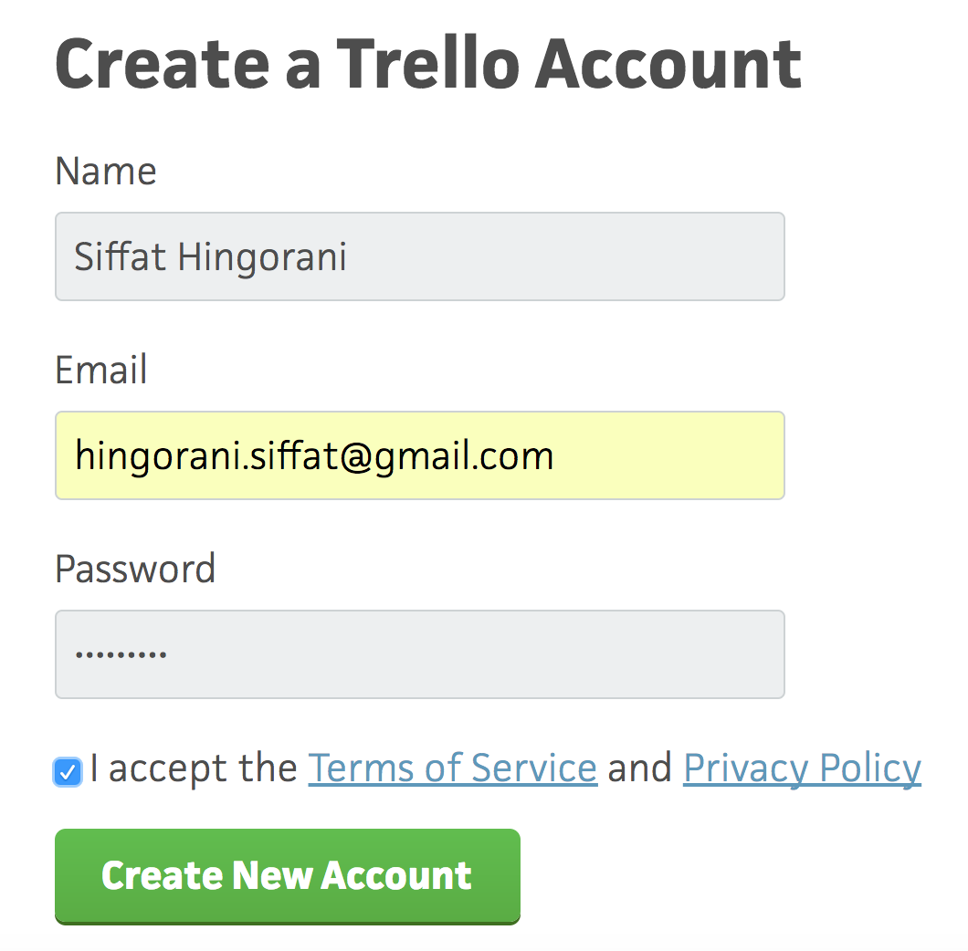
3. Bookmark this page for easy future reference.

**Part V: Create a GitHub Account**

1. Go to <https://github.com/>.
2. Sign up for a free account (unless you already have an account, in which case, you need not create a new one).
   1. When asked to choose your personal plan, select “Unlimited public repositories for free.”

**Part VI: Send me your info**

On the <insert LMS> Lab 0 Assignment page, respond with a comment indicating:

* The email address you used to create your Trello account. (I will then send you an invite to join our “Team Alexa.”)

Your GitHub username. (I will then send you an invite to join our GitHub organization “mson-team-alexa.”)

Once you receive these invites, please go ahead and join both. Then bookmark the pages for easy future reference.

**Congratulations!**

You have successfully completed your first lab!